

Lebanese International University

School of Engineering

CENG375- Introduction to Database systems

Spring 2022

Charbel Srour 52030290

Farah Al Mazaal

Fawzy Ghazawy 52030655

Teddy Nohra 52030362

Gemma Elia 51930562

Database Project

Hospital Management System.

# Introduction

 The Hospital management system (HMS) is a database design used for managing hospital functions and events. HMS also improve interactions between patients and their doctor. The software takes care of all the requirements of an average hospital and is capable to provide easy and effective storage of information related to patients that come up to the hospital. It provides the problem details including medical records, date of examination.

Each doctor is working in 1 hospital or not and each hospital has many doctors. Each doctor gives an appointment to many patients and vice versa. The patients may have many medical record, but this medical record belong to exactly one patient. The patients can enter many hospitals and the hospital has many patients.

# E/R model

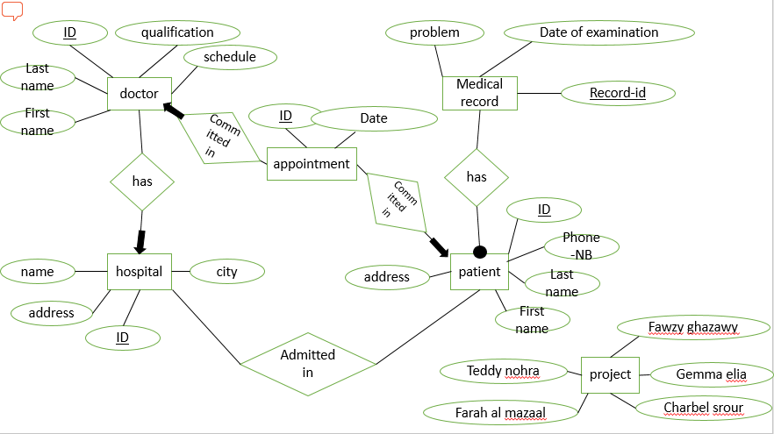

# Relational Model

Patient (ID, First name, Last name, Phone-Nb, Address)

Medical Record (Record-ID, Problem, Date of Examination, Patient -ID)

Doctor (DOCTOR-ID, First name, Last name, Qualification, Schedule, HOSPITAL -ID)

Hospital (HOSPITAL-ID, HOSPITAL-Name, HOSPITAL-Address, City)

Appointment (Appointment -ID, date, Patient –ID, Doctor-ID)

Admitted in (HOSPITAL-ID, Patient -ID)

# Queries

**Fawzy Ghazawy 52030655 Queries:**

1-Find the total number of doctor in specific Departments.

2-Find the total number of all patient in specific city.

3-Find the patients ID that have the same address of the hospital.

**Gemma Elia 51930562 Queries:**

1-Change the Address of the patient by ID.  
2-Add a new record to the Medical Record of any patient By his ID .

3-Find the ID of the doctor of any patient by his ID.

**Charbel Srour 52030290 Queries:**

1. Change the Schedule of the Doctor by Hospital ID.
2. Find all the appointments of the doctor by his ID.
3. Find the name of the Hospital that is in a specific city ‘koura’.

**Teddy Nohra 52030362 Queries:**

## Find the medical report of patient by his ID.

1. Cancel the Appointment of the Patient by his ID using his doctor ID.

## Queries to create the tables

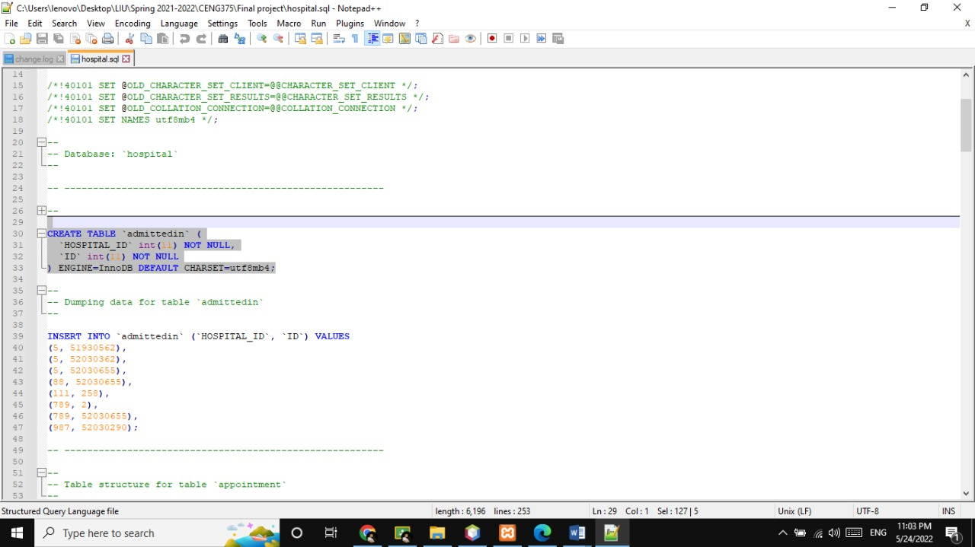

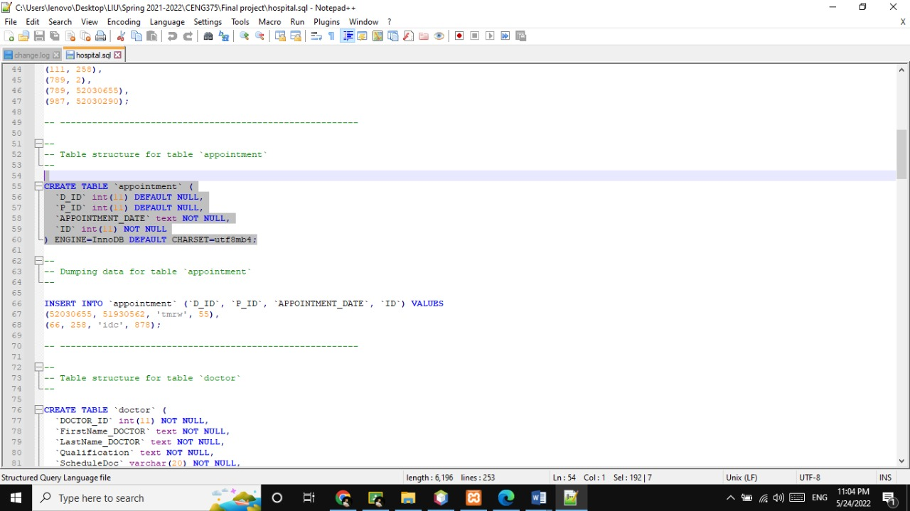

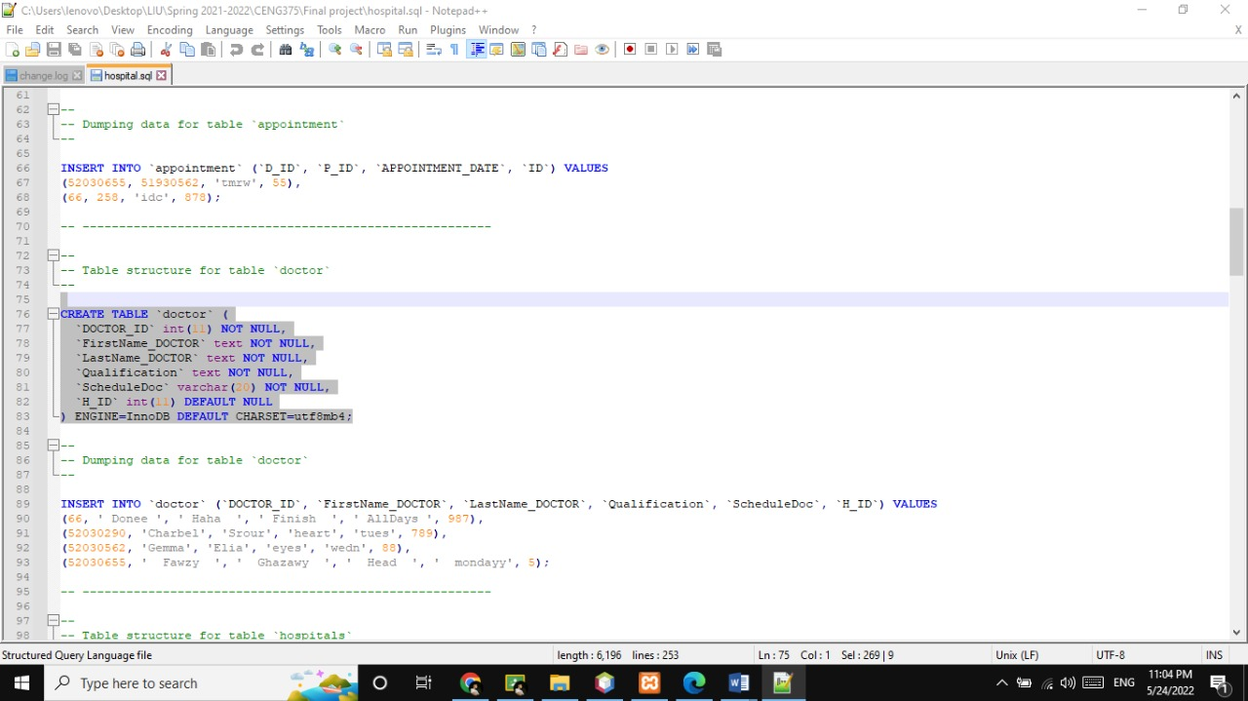

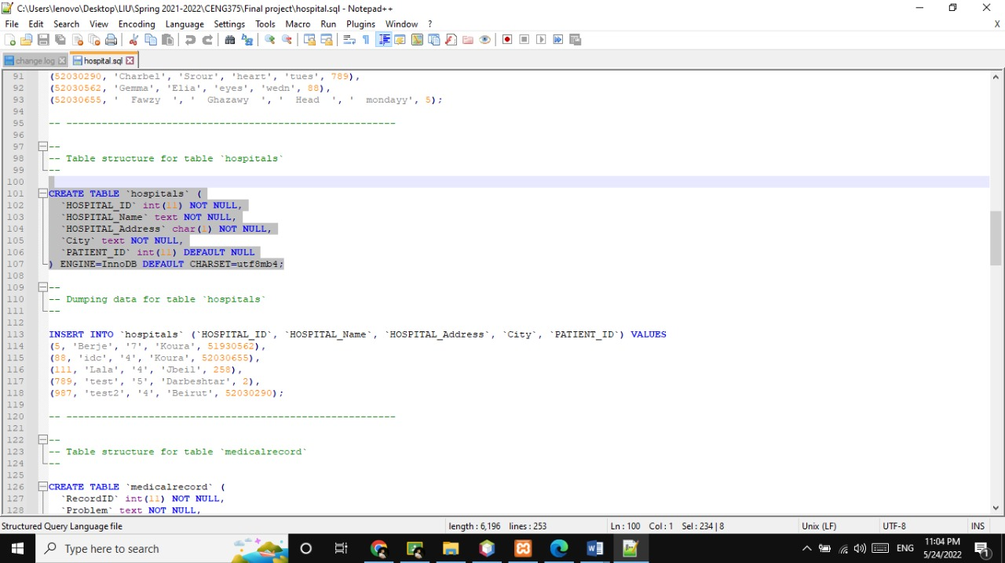

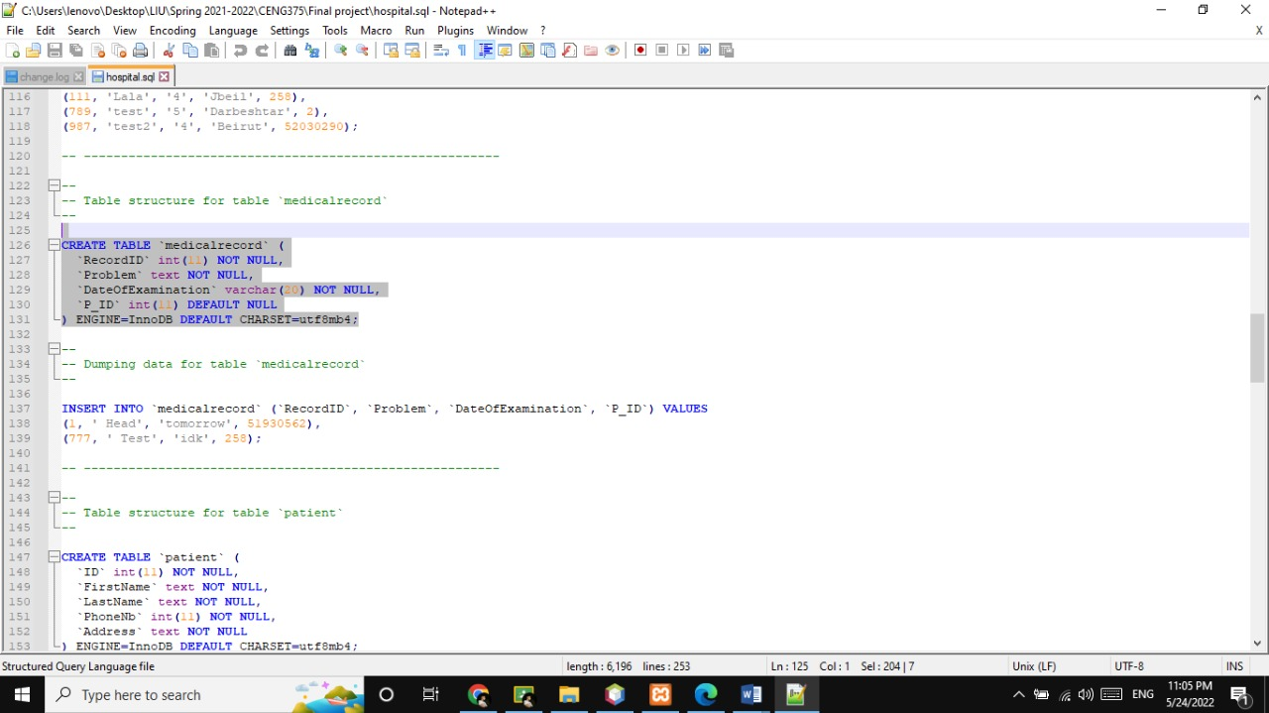

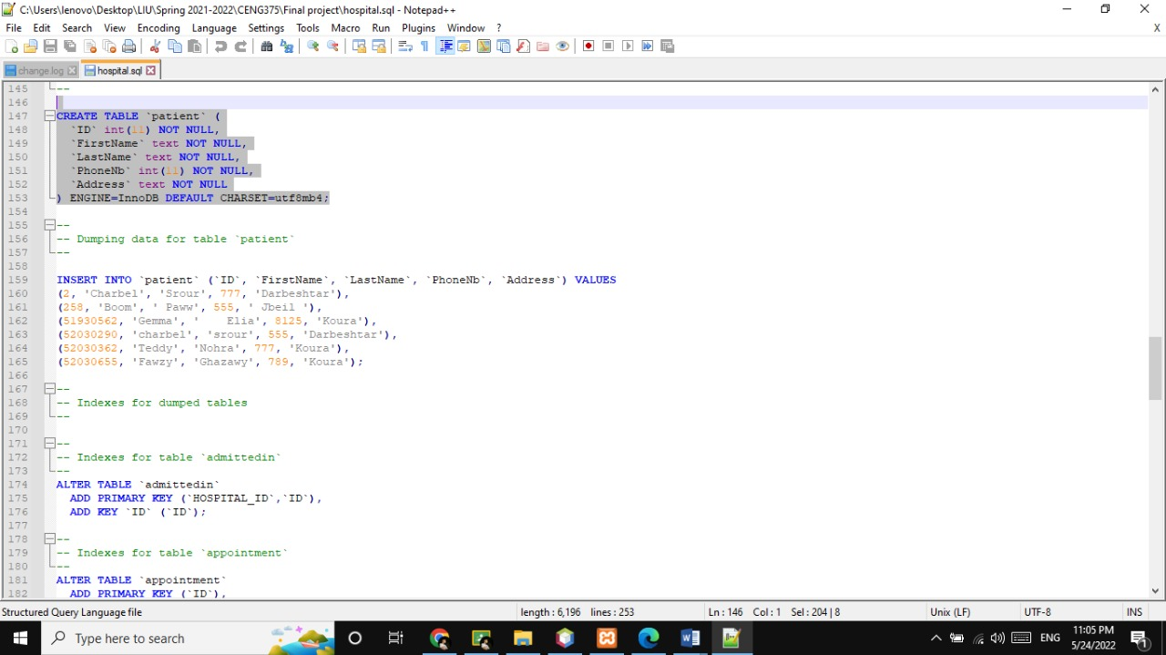

## Queries to insert data into Patient

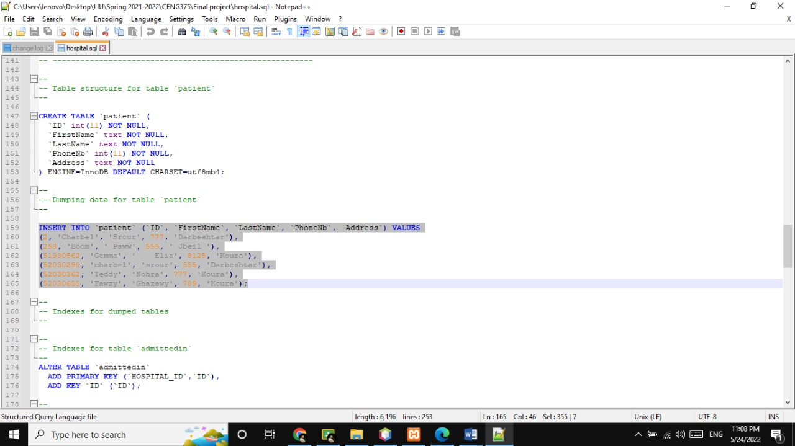

## Queries to insert into medical record

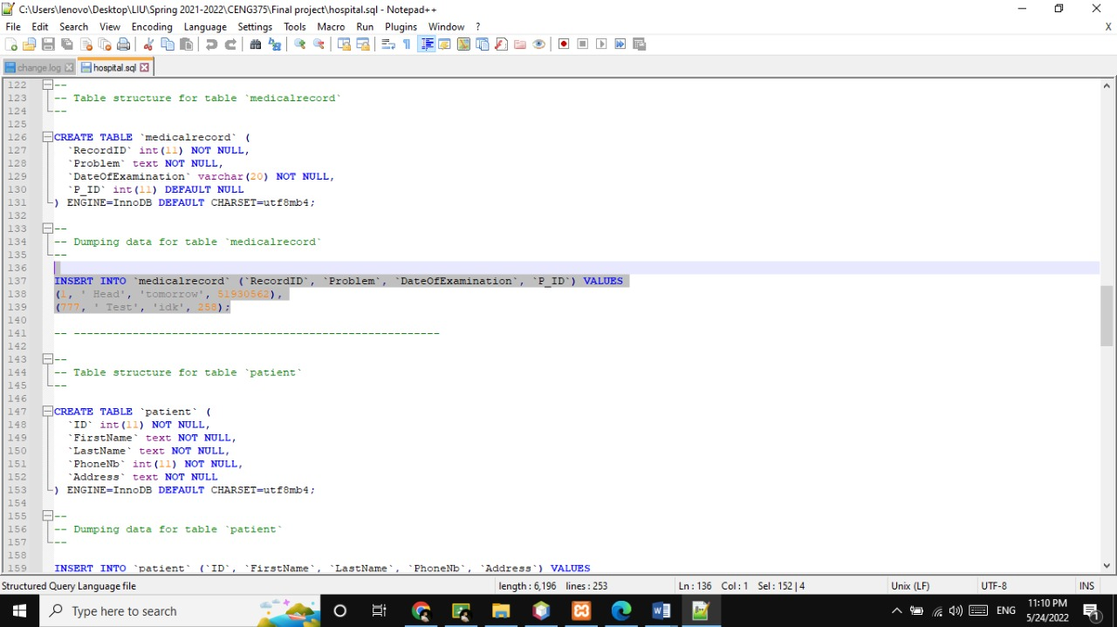

## Queries to insert into hospitals

## C:\Users\Gemma\Downloads\WhatsApp Image 2022-05-24 at 11.11.34 PM (2).jpeg

## Queries to insert into doctor

## C:\Users\Gemma\Downloads\WhatsApp Image 2022-05-24 at 11.11.59 PM.jpeg

## Queries to insert into Appointment

## C:\Users\Gemma\Downloads\WhatsApp Image 2022-05-24 at 11.16.09 PM.jpeg

## Queries to insert into Admitted in

## C:\Users\Gemma\Downloads\WhatsApp Image 2022-05-24 at 11.16.34 PM.jpeg

## Querying the database

### Find the total number of doctor in specific Departments

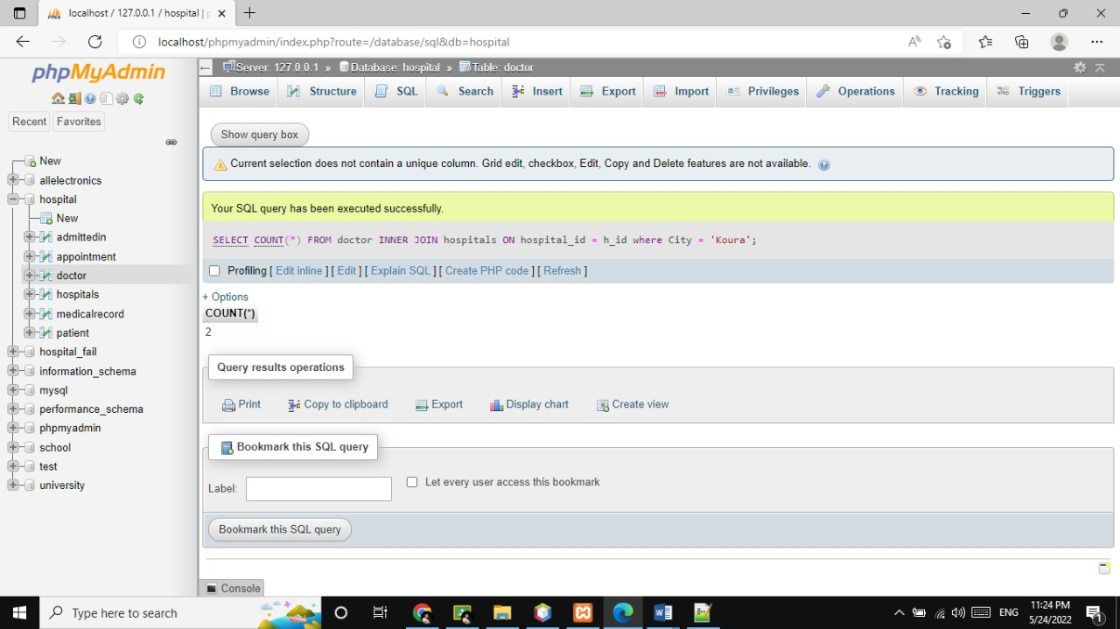

### Find the total number of all patient in Beirut.

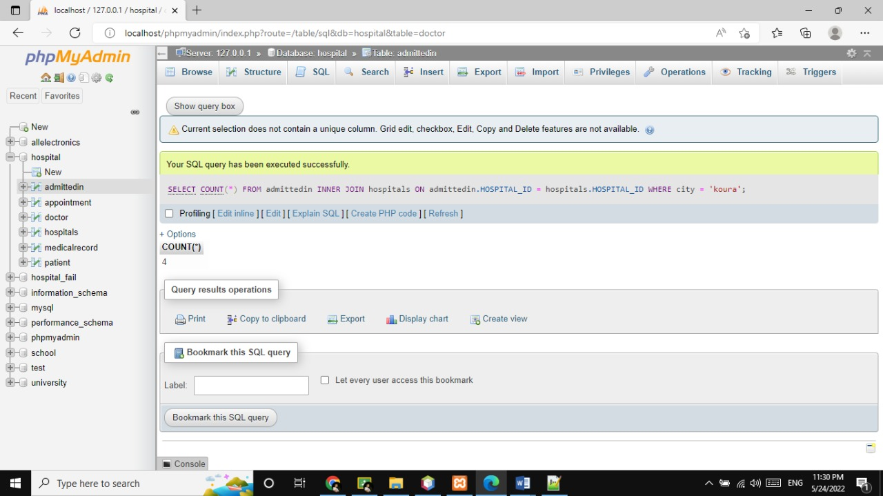

### Find the patients ID that have the same address of the hospital.

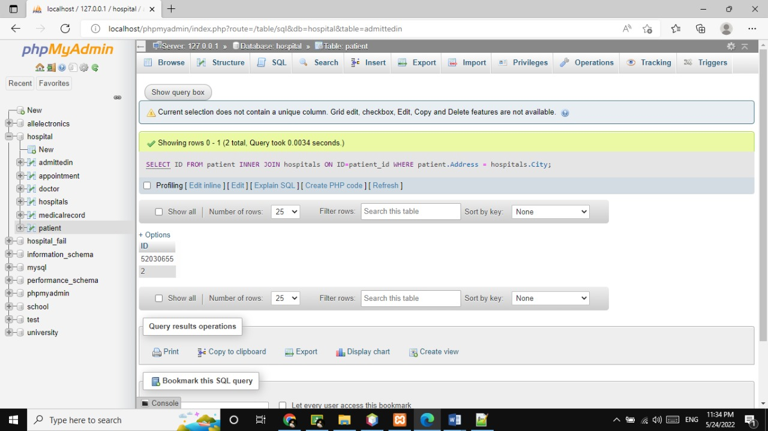

### Change the Address of the patient by ID.

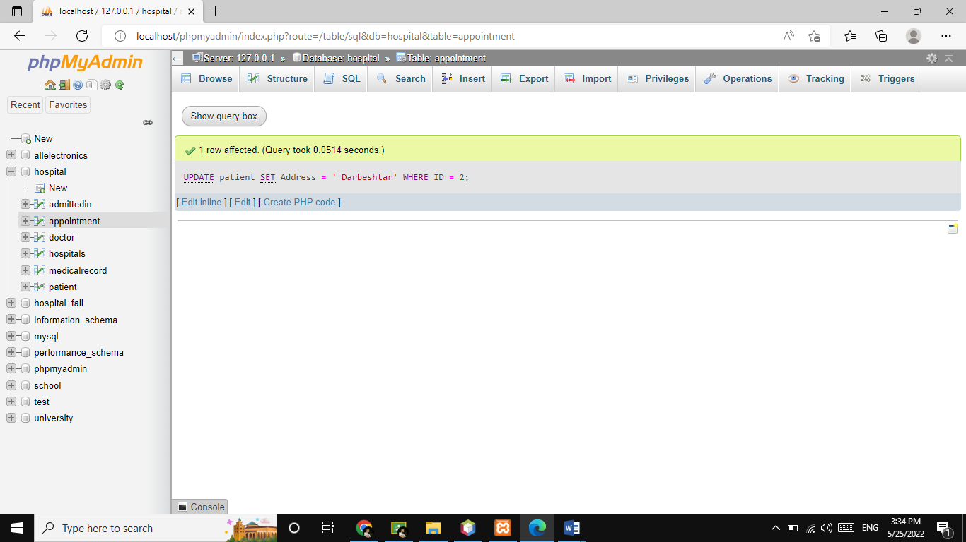

### Add a new record to the Medical Record of any patient by his ID.

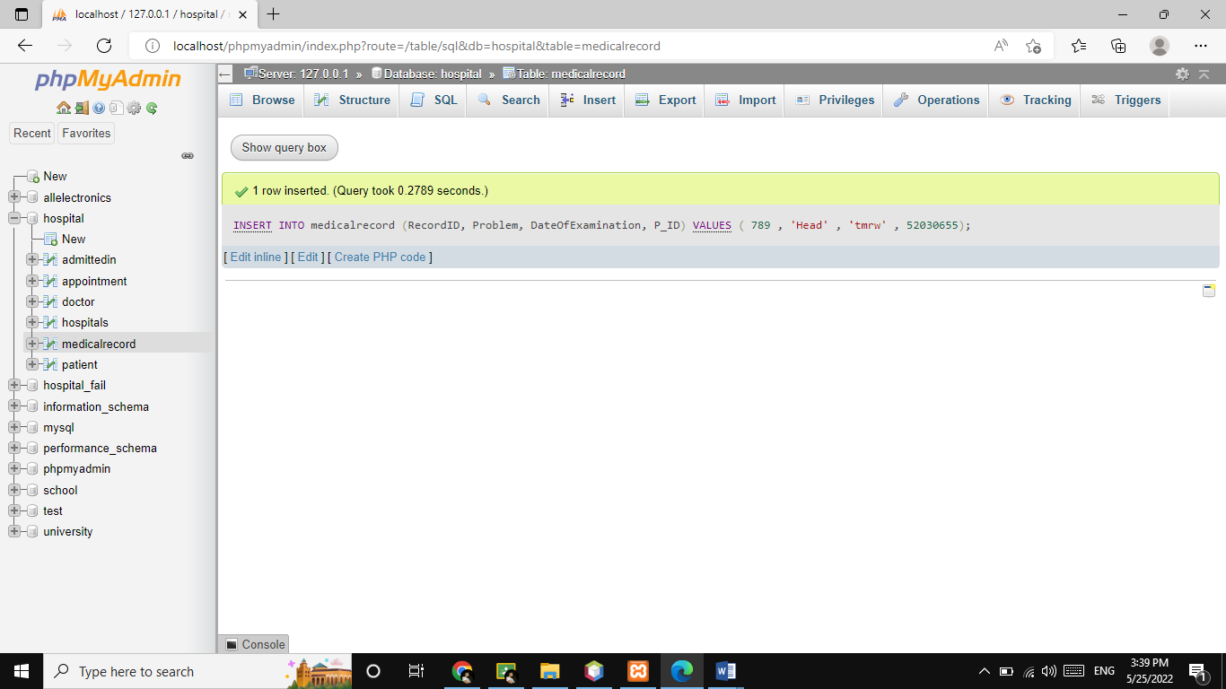

### Find the ID of the doctor of any patient by his ID.

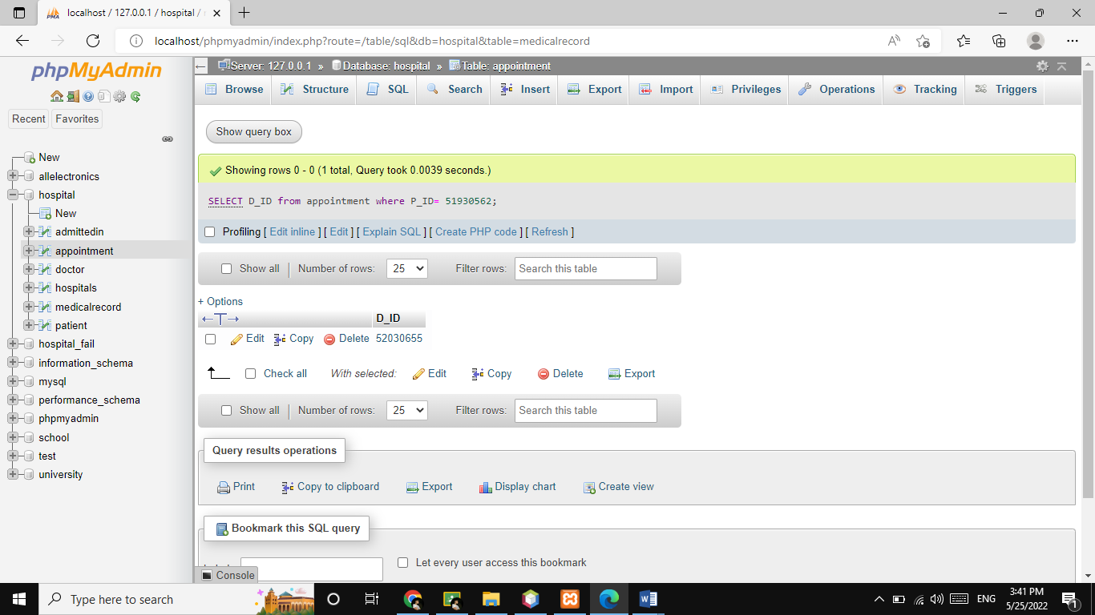

**4.8.7 Change the Schedule of the Doctor by Hospital ID.**

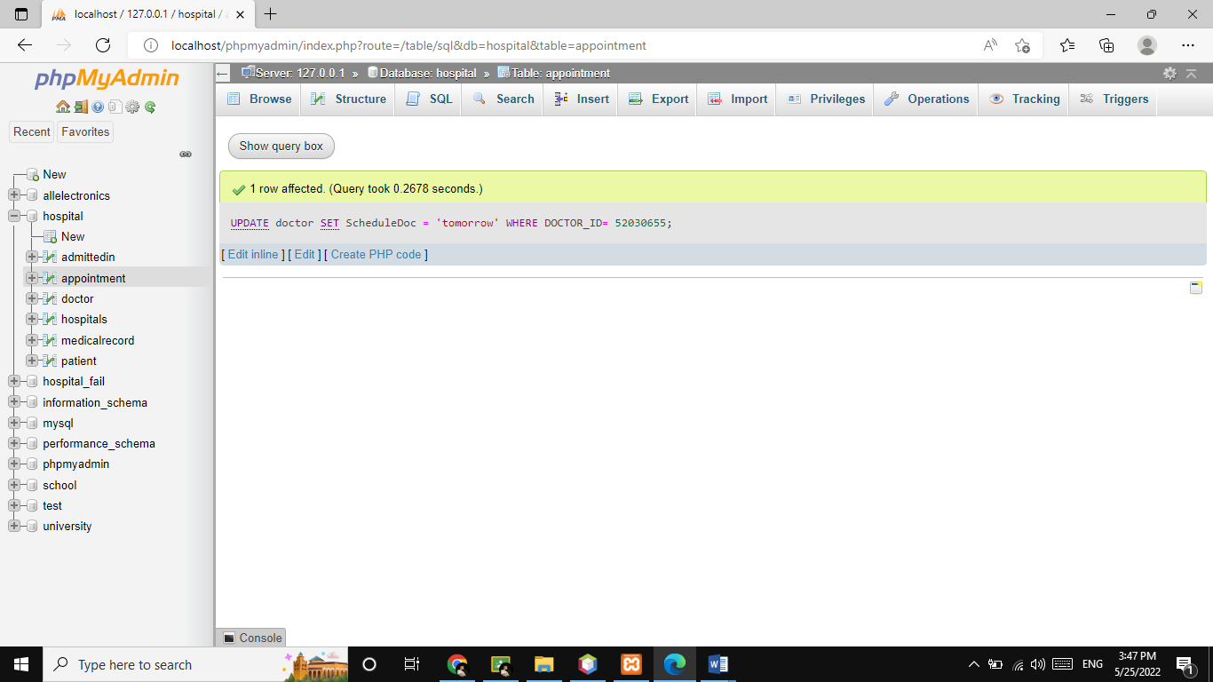

**4.8.8 Find all the appointments of the doctor by his ID.**

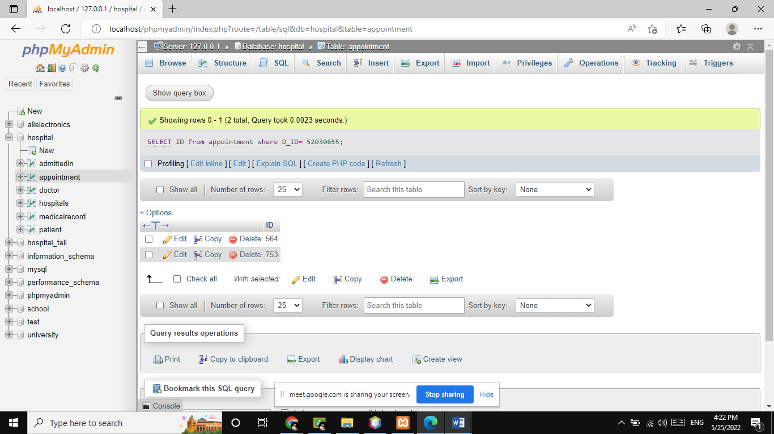

**4.8.9 Find the name of the Hospital that is in a specific city ‘koura’.**

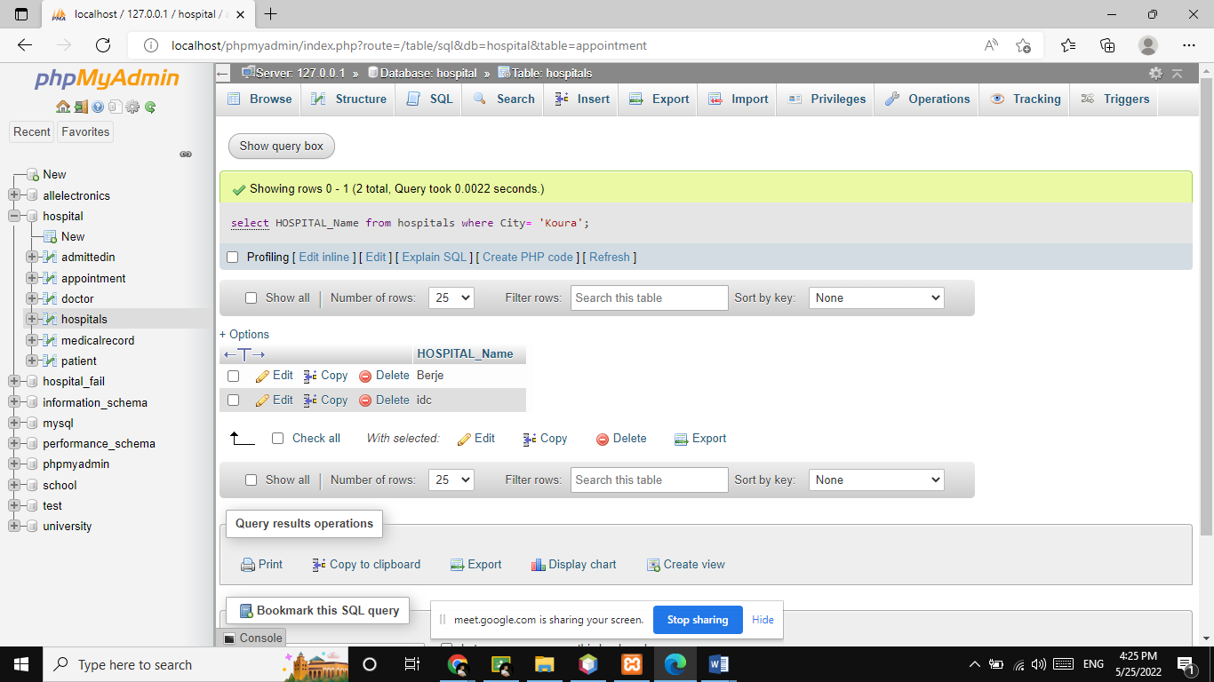

**4.8.10 Find the medical report of patient by his ID.**

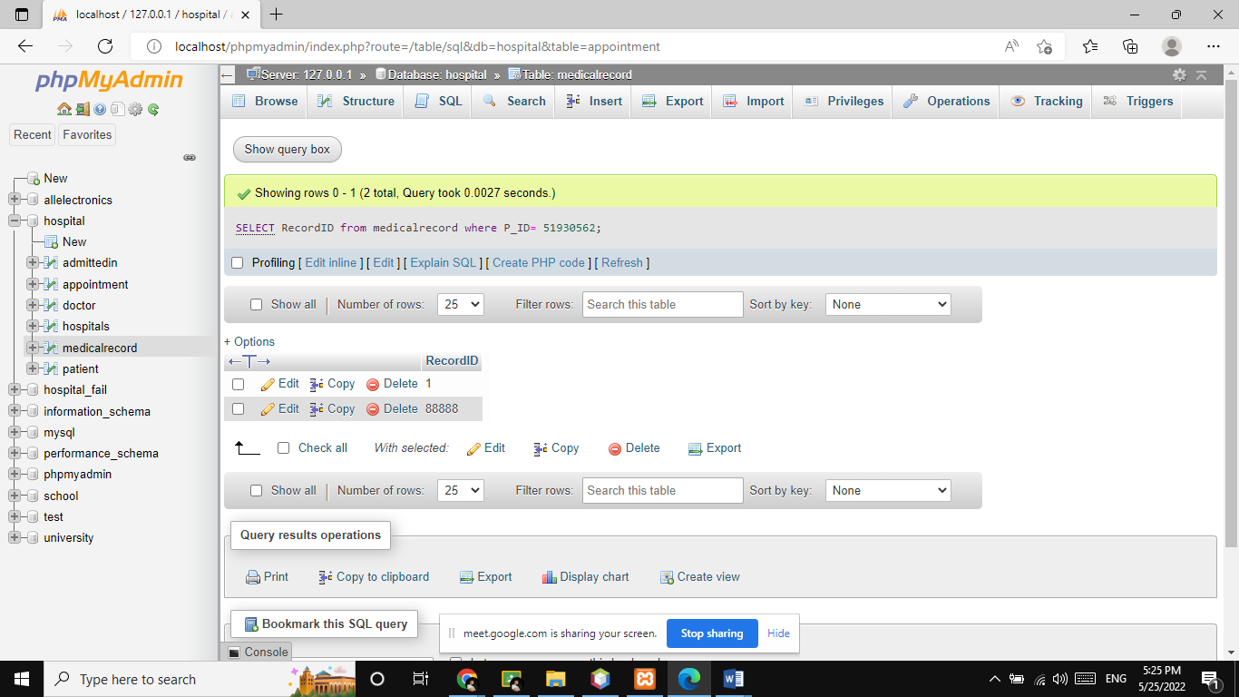

**4.8.11 Cancel the Appointment of the Patient by his ID using his doctor ID.**

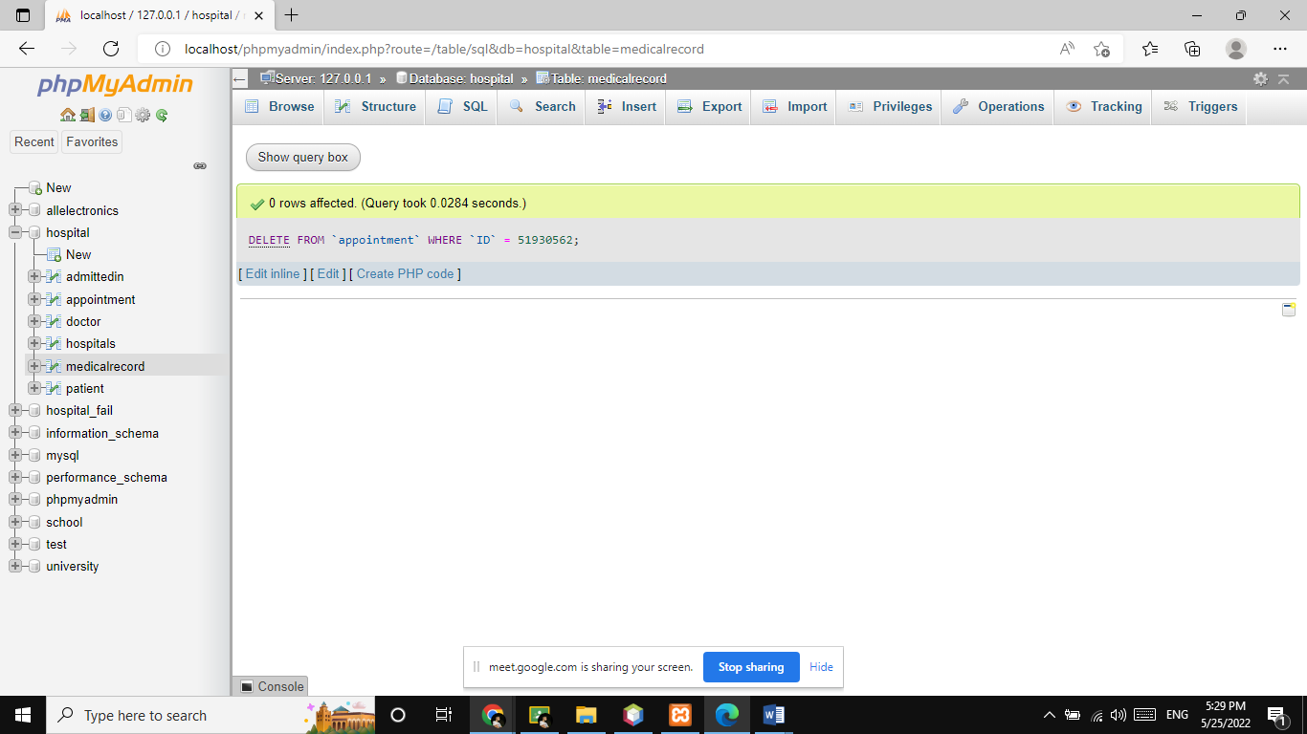

# Layout

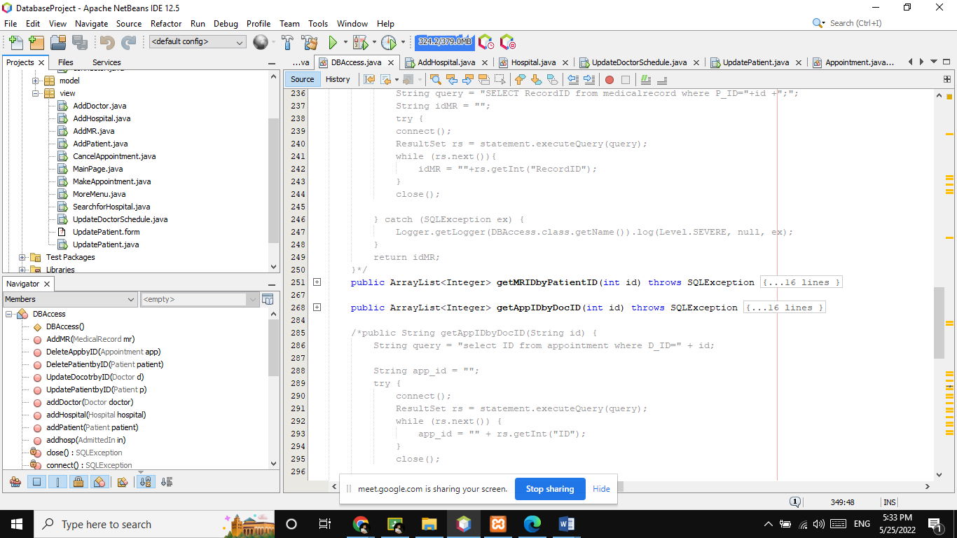

* AddDoctor: to add a new doctor (ID, First name, Last name, Qualifications, Schedule, Hospital ID).
* AddHospital: to add a new hospital (ID, Name, Address, City, Patient ID).
* AddMR: to add a new medical record (ID, Problem, Date, Patient ID).
* AddPatient: to add a new patient (ID, Fist name, Last name, Phone number, Address).
* Cancel appointment: to cancel an appointment (Doctor ID, Patient ID).
* Main page (section 5.1).
* Make Appointment: to make a new appointment (Doctor ID, Patient ID, Appointment Date, ID).
* More menu (Patient information, Doctor information, hospital, appointment).
* Patient information: to display the queries on the patients and display its information.
* Doctor information: to display the queries on the doctors and display its information.
* Hospital: to display the queries on the hospital and display its information.
* Appointment: to display the queries on the appointments and display its information.

**Main layout**

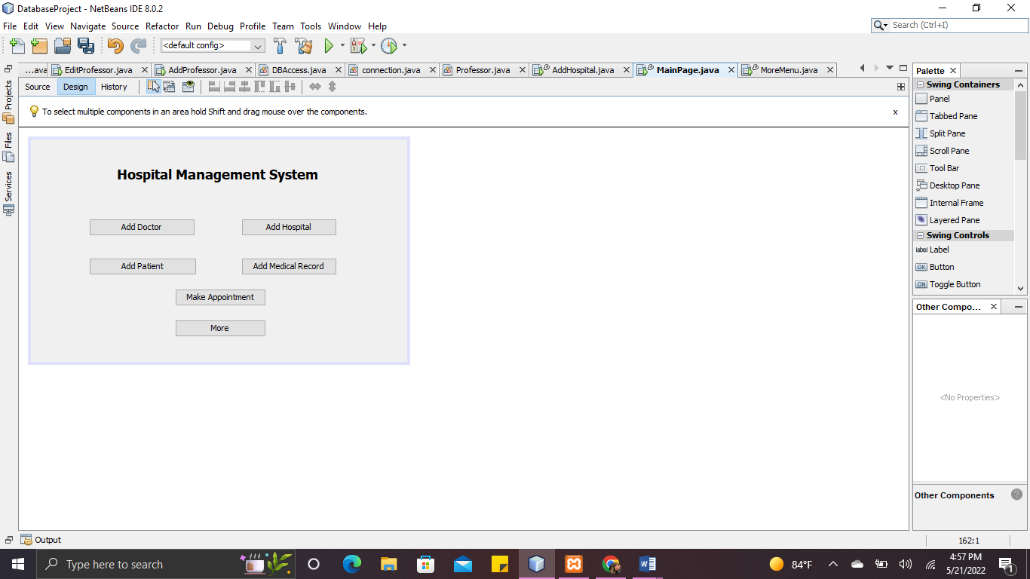

## Hospital Management System

### Add Doctor

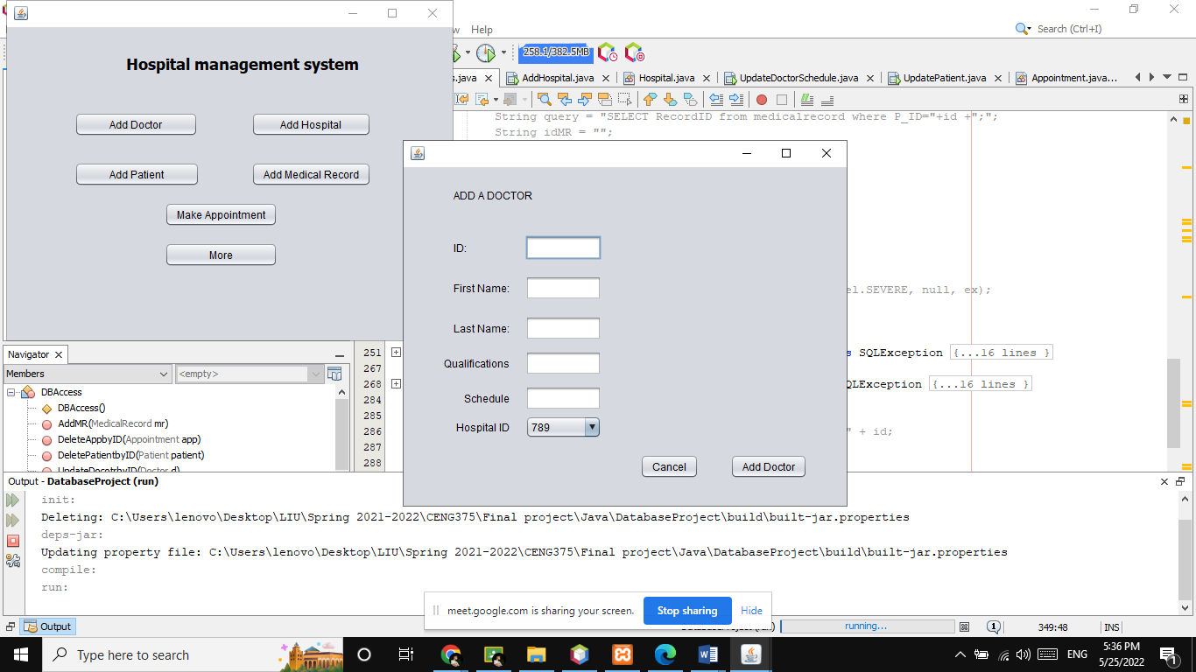

### Add Patient

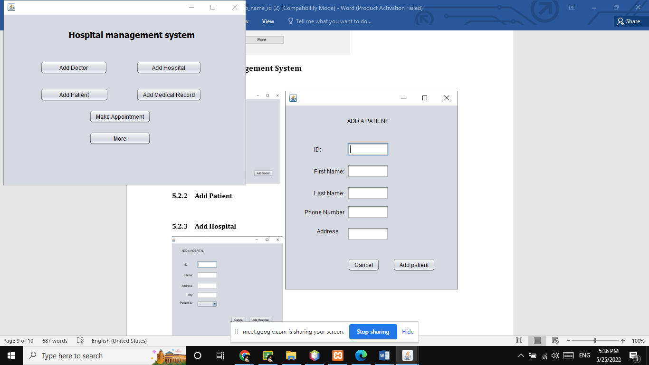

### Add Hospital

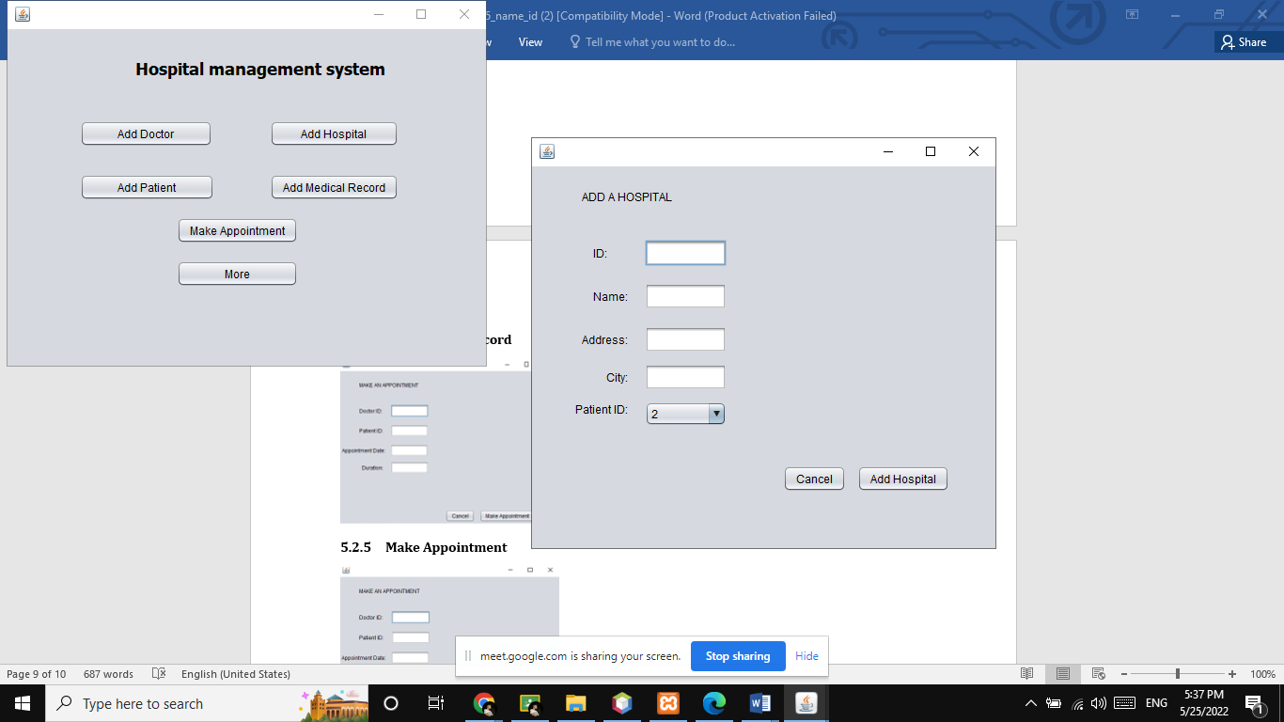

### Add Medical Record

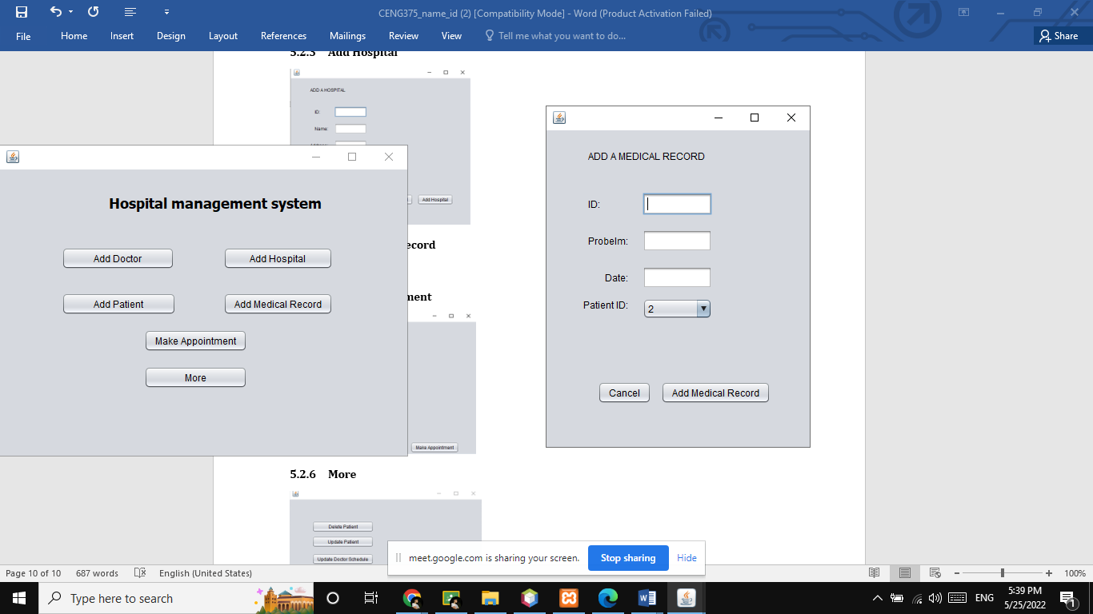

### Make Appointment

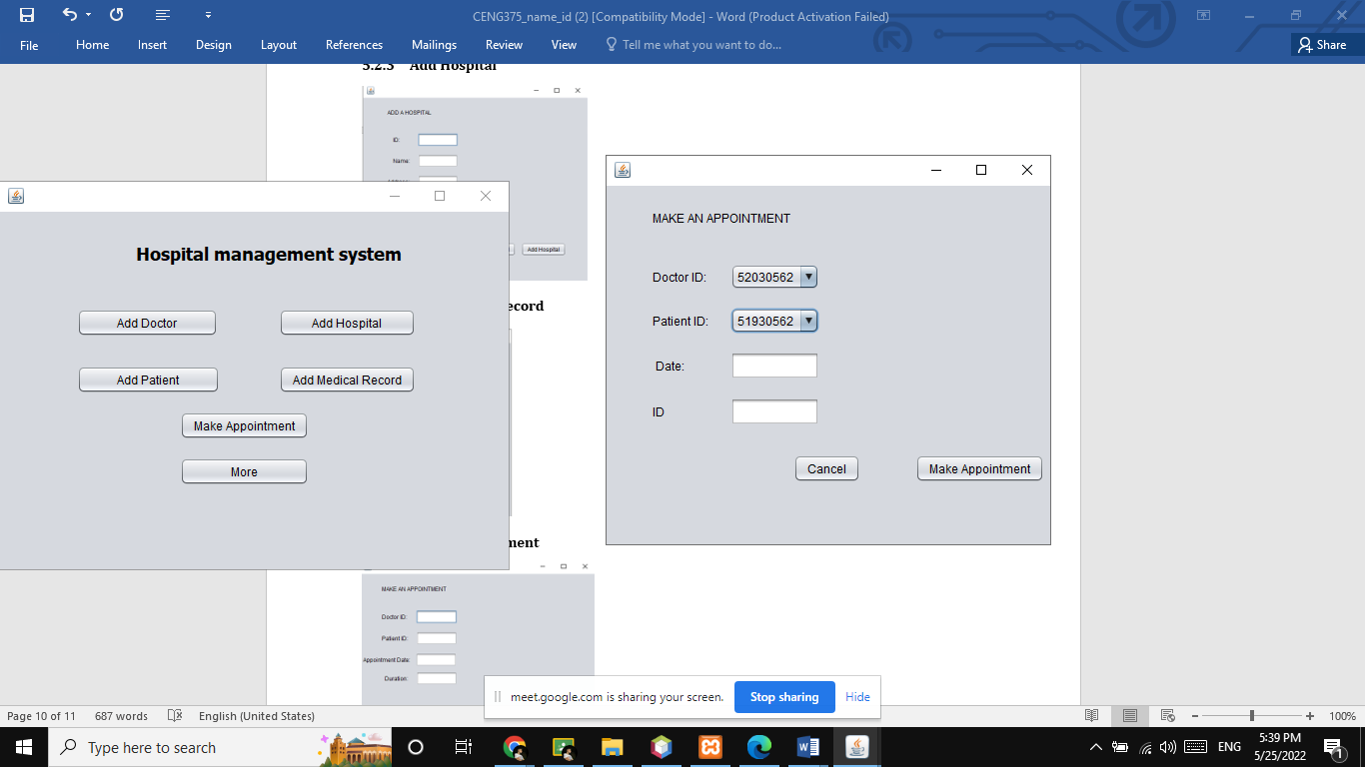

### More

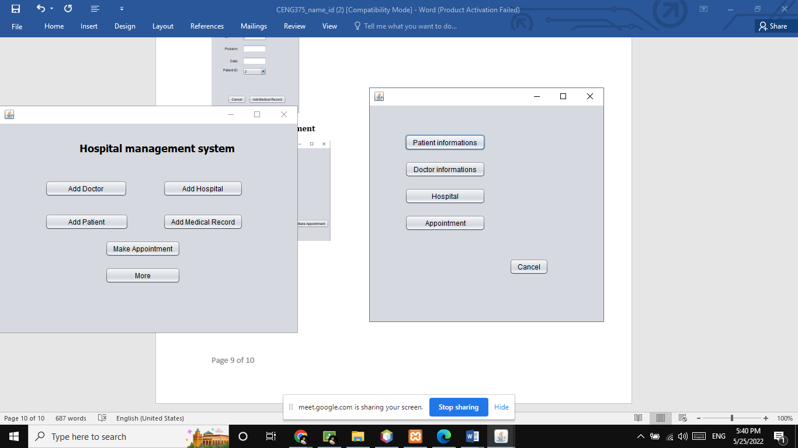

**5.2.7 Patient information:**

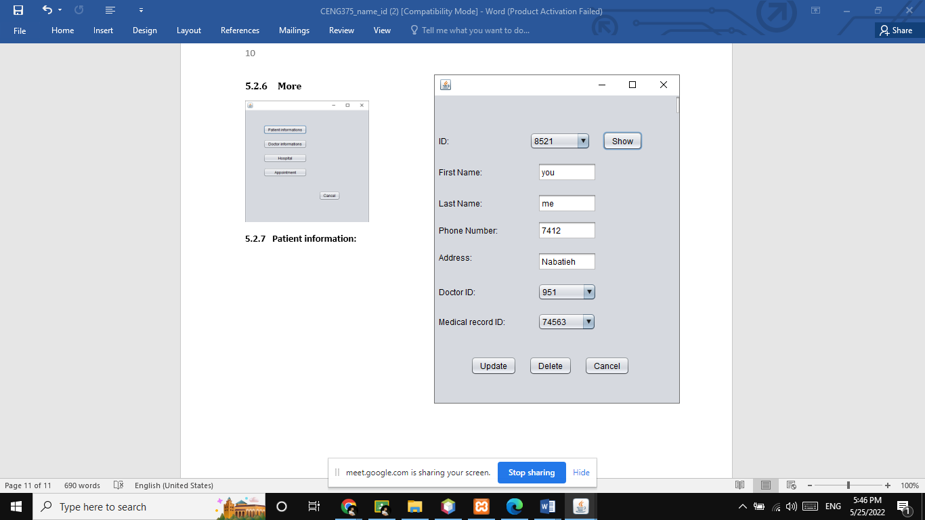

**5.2.8 Doctor information:**

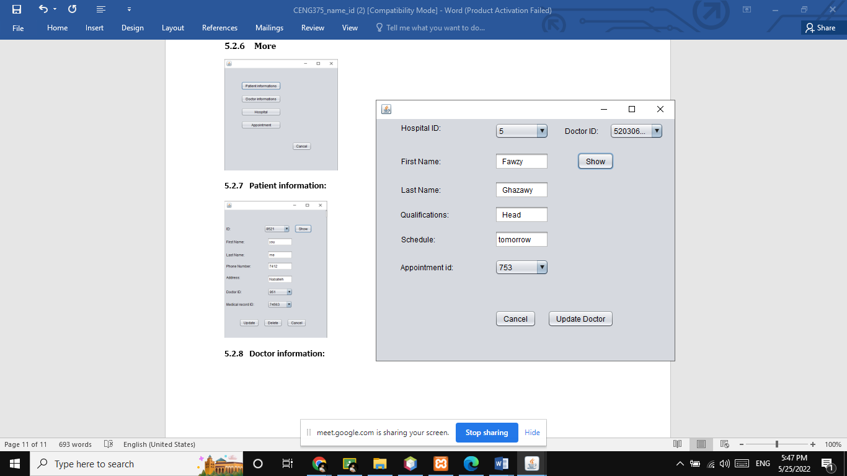

**5.2.9 Hospital:**

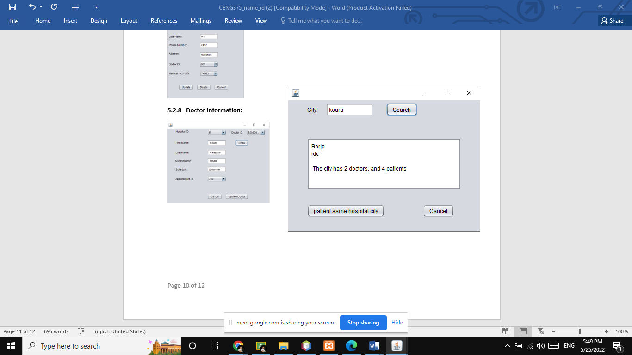

**5.2.10 Appointment:**

